Snacks

What do healthy snacks look like?

**Avoid sugary snacks**

Cookies, pastries, candies are packed with sugar and leave you feeling hungry.

**Lots of Fiber**

Fruits, Vegetables and nuts are all great sources of fiber which keeps you fuller longer.

**Enjoy protein rich foods**

Nuts, hard boiled eggs, cheese, or yogurt are great to keep you full.

**Make Snacks a combination**

For example, combine a healthy carbohydrate with a healthy fat. This helps you feel fuller longer and provides you with a great punch of nutrients

**Choose healthy fats**

Nuts, peanut butter and avocados are great sources of healthy fat that keeps your heart healthy and your stomach full.

Healthy Choices

[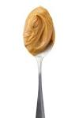](https://www.google.com/url?q=http://www.goodhousekeeping.com/food-recipes/healthy/news/a19134/peanut-butter-breakfast-recipes/&sa=U&ved=0ahUKEwiF7rzwp7PSAhWowlQKHfAdBvAQwW4IGDAB&usg=AFQjCNGFcqwdUfGf7e6_w5oCrLMRJtPYRA)

[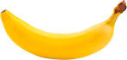](https://www.google.com/url?q=https://www.pinterest.com/sptrcook/banana-phones/&sa=U&ved=0ahUKEwji6vfbp7PSAhUJrFQKHWenCKgQwW4IIjAG&usg=AFQjCNHD9xGfQ66Vq5lZUpsKGQl2Y0NRJg)

**Veggie sticks and string cheese**

[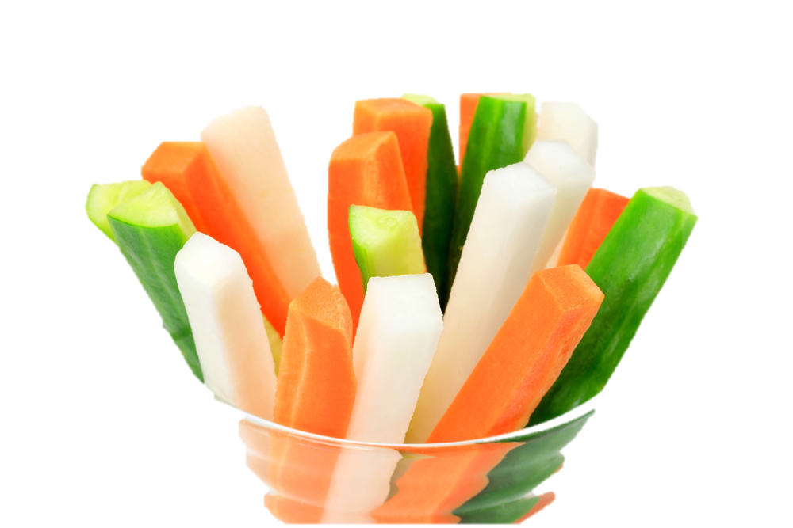](http://running.competitor.com/2013/11/photos/5-simple-ways-to-eat-more-vegetables_13790)

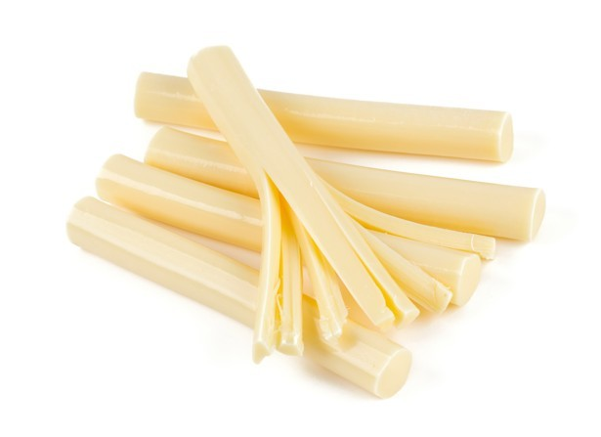

**Banana and Peanut butter**

**[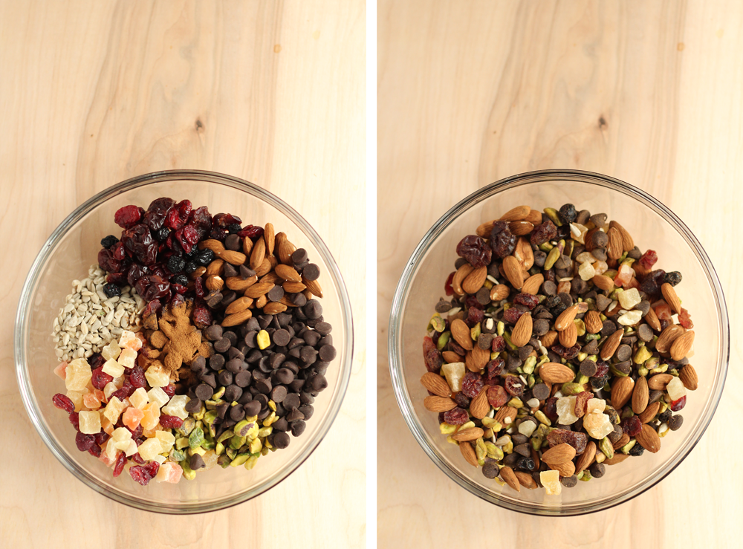](http://www.chardincharge.com/wp-content/uploads/2015/05/trailmix101_1.png)**

**Trail mix**

* **Choose nuts with dried fruits**
* **Avoid mixes with added sweets such as m&m’s and other candies (but if you must have a little sweetness choose dark chocolate**
* **Choose low sodium trail mixes**
* **Avoid mixes with added sugars**

$18 BUY NOW
Packed with cashews, almonds, dried berries, and yogurt chips, this snack is as tasty as a dessert without all those extra calories. 
More: The Best Dried Fruit for Summer Snacking 


$21 BUY NOW
It's no surprise that Costco's store brand offers a whopping a 4-pound bag of trail mix (so you never run out). The salty-sweet blend has everything you would expect in the typical blend: peanuts, raisins, M&Ms, almonds, and cashews. It's great to take on a road trip or as a quick snack when kids get hungry.


[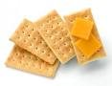](https://www.google.com/url?q=http://recipegreat.com/1366-cheese-and-crackers.html&sa=U&ved=0ahUKEwiV9IW3mrjSAhWhgFQKHXvaC4QQwW4IFjAA&usg=AFQjCNG7c6N0_hAu1XeHkrZ5kDlRoylUKw)

**Yogurt, fruit and granola**

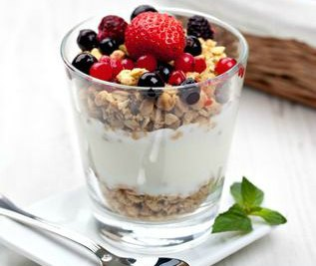

[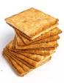](https://www.google.com/url?q=http://www.womansday.com/health-fitness/nutrition/a2657/5-things-you-didnt-know-about-carbs-124229/&sa=U&ved=0ahUKEwiNq8-PnrjSAhXKi1QKHXuIAN0QwW4IHDAD&usg=AFQjCNEyXz3P8vwZReI8s05K79XjbTCSbQ)

**Avocado with whole grain crackers**

[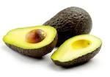](https://www.google.com/url?q=http://snowfoxnews.com/2015/12/11/announcing-a-specification-for-php-2/&sa=U&ved=0ahUKEwi696blnbjSAhULiVQKHf4_A2M4FBDBbgg0MA8&usg=AFQjCNFGNpu_Kn-W2QZ0LgZv935DeOQhOQ)

**Cheese and whole grain crackers**

**Granola Bar Tips**

Choose a bar with less than eight grams of sugar.

Protein in your granola bar should come from nuts, seeds, or nut/seed butter

Contains healthy fats: nuts, seeds, flax

Sweetened naturally such as with dried fruit. Avoid added sugars

Look for a short ingredient list

|  |  |
| --- | --- |
| Serving Size | 1 Bar (40g) |
| Calories | 200 |
| Fat Calories | 130 |
| Total Fat | 15g (23% DV) |
| Saturated Fat | 3.5g (18% DV) |
| Trans Fat | 0g |
| Cholesterol | 0mg |
| Sodium | 120mg (5%) |
| Potassium | 200mg (6%) |
| Total Carb | 16g (5%) |
| Dietary Fiber | 6g (24%) |
| Sugars* | 5g |
| Protein | 5g |



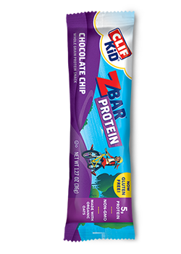

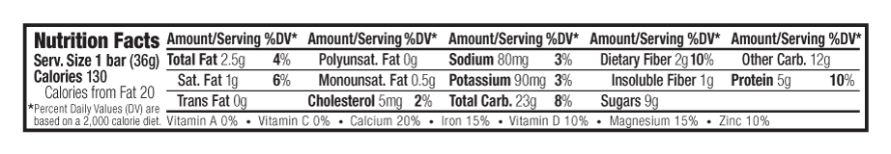

Unhealthy Choices

**Nutrition Facts**

Serving Size 1 Bar (31g)

**Amount per Serving**

**Calories** 140

Calories from Fat 45

%Daily Value*

**Total Fat** 5g

8%

Saturated Fat 4g

20%

Trans Fat 0g

Polyunsaturated Fat 0g

Monounsaturated Fat 1g

**Cholesterol** 0mg

0%

**Sodium** 60mg

3%

**Total Carbohydrate** 23g

8%

Dietary Fiber 1g

4%

Sugars 13g

Sugar Alcohol 1g

Other Carbohydrate 8g

**Protein** 1g

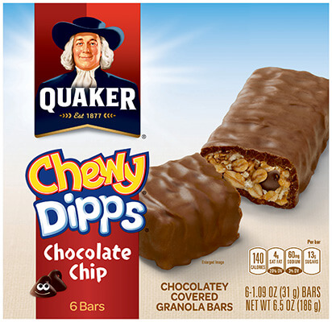

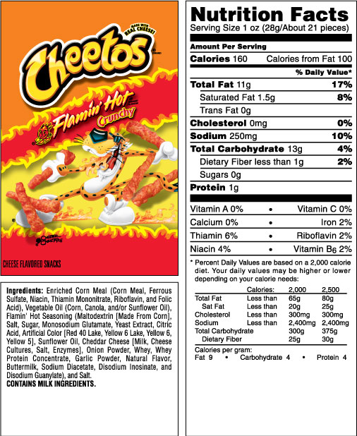

[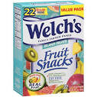](https://www.google.com/url?q=http://www.sherisstoretodoor.com/product/welchs-island-fruits-fruit-snacks-pouches-9oz-22count/&sa=U&ved=0ahUKEwjb8L-s9LjSAhWKsFQKHVivBzYQwW4IJjAI&usg=AFQjCNElhA57P0BrPyQNt-G-LLfY89R5pA)

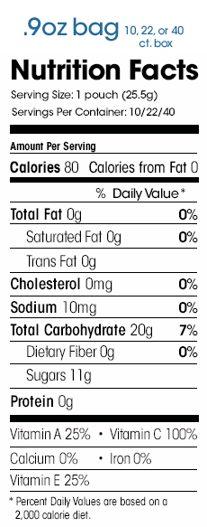

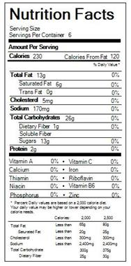

[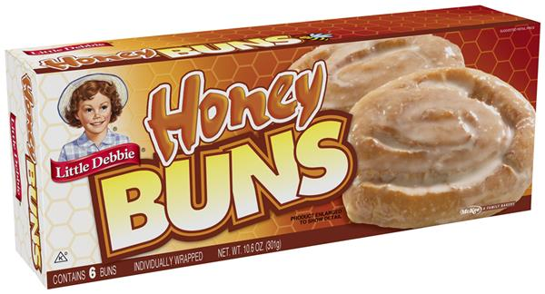](https://e22d0640933e3c7f8c86-34aee0c49088be50e3ac6555f6c963fb.ssl.cf2.rackcdn.com/0024300041020_CL_version_type_large.jpeg)